**EXPERIMENT 1:**

**To Perform Various Commands in sql in oracle:**

•Find the name, street address, and cities of residence of all employees who work for FBC and earn more than $10,000.

select e.empname, e.street, e.city from Employee e join Works w on w.empname = e.empname where w.compname = 'FBC' and salary > 10000;



• Find all employees who live in the same cities.  
select city, count(empname) from Employee group by city;

•Find the company with the smallest pay roll

•Find the average salary for all employees.

select avg(salary) from Works;



• Find the Employee who receives the lowest pay.  
select * from Works where salary in (select min(salary) from Works);

•Find the Maximum salary of employee in particular company.

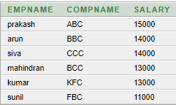

•Sort the employee names according to their salary.

select empname, salary from Works order by salary;

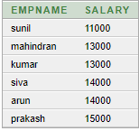

•Find the Employee name that who works under same manager.

select empname, managername from Manager;

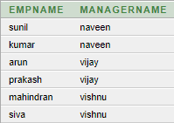

•Insert a new employee to a database, and update the table.

insert into Employee(empname, street, city) values ('suresh', 'west', 'bengal');

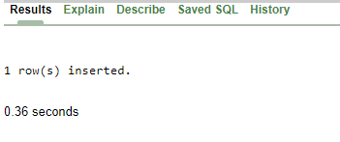

•Give the names of the employees living in the same city where their company is located.

select e.empname from Employee e join Works w on e.empname = w.empname join Company c on w.compname = c.compname and e.city = c.city;

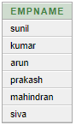

•Give the name of manager and salary of employee SUNIL.

select m.empname, w.salary, m.managername from Manager m join Works w on w.empname = m.empname where m.empname = 'sunil';

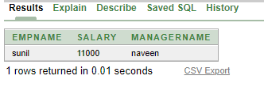

**RESULT:**

**EXPERIMENT 2**

**Star Schema:**

create table time(time_key varchar(45) primary key, day varchar(45), day_of_the_week varchar(45),month varchar(45),quarter varchar(45),year varchar(45));

insert into time(time_key, day, day_of_the_week,month,year) values ('t1','12', 'monday', 'may','1997');

insert into time(time_key, day, day_of_the_week,month,year) values ('t2','11', 'sunday', 'june','1998');

select * from time; create table branch_1(branch_key varchar(45) primary key, branch_name varchar(45), branch_type varchar(45));

insert into branch_1(branch_key, branch_name, branch_type) values ('b1','maduraieast', 'wholesale');

insert into branch_1(branch_key, branch_name, branch_type) values ('b2','maduraiwest', 'retail');

select * from branch_1;

drop table branch_1;

create table item(item_key varchar(45) primary key, item_name varchar(45), brand varchar(45),type varchar(45),supplier_type varchar(45));

insert into item(item_key, item_name, brand,type,supplier_type ) values ('i1','bottle', 'sony', 'plastic','factory');

insert into item(item_key,item_name,brand,type,supplier_type ) values ('i2','tv', 'samsung', 'electronic','dealer');

select * from time; create table location(location_key varchar(45) primary key, street varchar(45), city_key varchar(45),state varchar(45),country varchar(45));

insert into location(location_key, street, city,state,country) values ('l1','a_street', 'madurai', 'tamilnadu','india');

insert into location(location_key, street, city,state,country) values ('l2','b_street', 'guntur', 'andra','india');

select * from location; select * from time;

create table sales_fact(time_key varchar(45), branch_key varchar(45) , item_key varchar(45),location_key varchar(45));

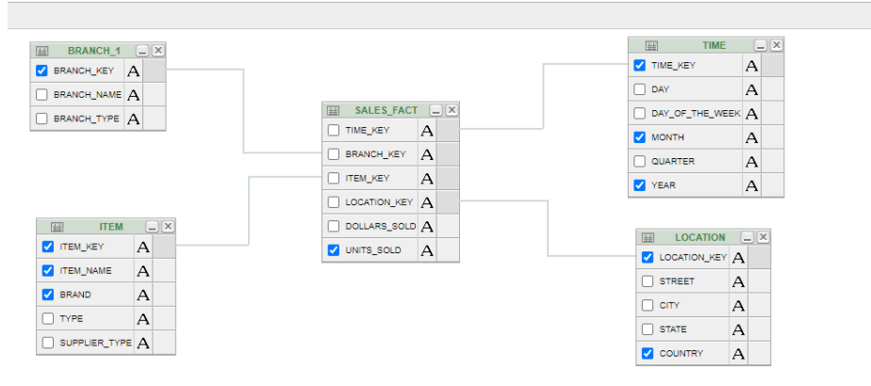

**Snowflake Schema:**

create table time(time_key varchar(45) primary key, day varchar(45), day_of_the_week

varchar(45),month varchar(45),quarter varchar(45),year varchar(45));

insert into time(time_key, day, day_of_the_week,month,year) values ('t1','12', 'monday',

'may','1997');

insert into time(time_key, day, day_of_the_week,month,year) values ('t2','11', 'sunday',

'june','1998');

select * from time;

create table branch_1(branch_key varchar(45) primary key, branch_name varchar(45),

branch_type varchar(45));

insert into branch_1(branch_key, branch_name, branch_type) values ('b1','maduraieast','wholesale');

insert into branch_1(branch_key, branch_name, branch_type) values ('b2','maduraiwest','retail');

select * from branch_1;

drop table branch_1;

reate table supplier(supplier_key varchar(45) primary key, supplier_type varchar(45));

insert into supplier(supplier_key,supplier_type)values("s1","wholesale");

insert into supplier(supplier_key,supplier_type)values("s2","retail");

select * from supplier;

drop table supplier;

create table city(city_key varchar(45) primary key, city varchar(45), province_or_state

varchar(45),country varchar(45));

insert into city(city_key,city,province_or_state,country)values("c1","madurai","tamilnadu","india");

insert into city(city_key,city,province_or_state,country)values("c2","washington","colombia","usa");

create table shipping_fact(item_key varchar(45) , time_key varchar(45), shipper_key

varchar(45),from_location varchar(45),to_location varchar(45),dollers_cost

varchar(45),units_shipped varchar(45));

create table shipper(shipper_key varchar(45), shipper_name varchar(45), location_key

varchar(45),shipper_type varchar(45));

insert into shipper(shipper_key,shipper_name,location_key,shipper_type)values("s1","sony","l1","wholesale");

insert into shipper(shipper_key,shipper_name,location_key,shipper_type)values("s2","samsung","l2","retail");

create table location1(location_key varchar(45) primary key, street varchar(45), city_key

varchar(45));

insert into location1(location_key,street,city_key)values("l1","a_street","madurai");

insert into location1(location_key,street,city_key)values("l2","b_street","washington");

create table sales_fact(time_key varchar(45), branch_key varchar(45) , item_key

varchar(45),location_key varchar(45),doller_sold varchar(45),unit_sold varchar(45));

insert into

sales_fact(time_key,branch_key,item_key,location_key,doller_sold,unit_sold)values("t1","b1","i1","l1","120","7");

insert into sales_fact(time_key,branch_key,item_key,location_key,doller_sold,unit_sold)values("t2","b2","i2","l2","240","9");

create table item_1(item_key varchar(45) primary key, item_name varchar(45), brand

varchar(45),type varchar(45),supplier_key varchar(45));

insert into item_1(item_key,item_name,brand,type,supplier_key)values("i1","tv","sony","led","s1");

insert into item_1(item_key,item_name,brand,type,supplier_key)values("i2","washingmachine","lg","wash+drying","s2");

create table location(location_key varchar(45) primary key, street varchar(45), city_key

varchar(45),state varchar(45),country varchar(45));

insert into location(location_key, street, city,state,country) values ('l1','a_street', 'madurai','tamilnadu','india');

insert into location(location_key, street, city,state,country) values ('l2','b_street', 'guntur',

'andra','india');

select * from location;

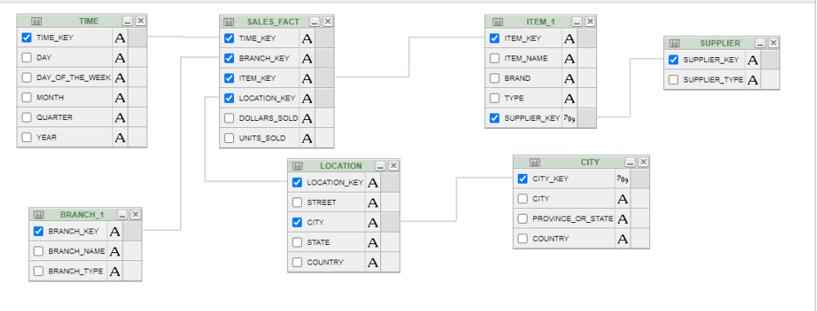

**Fact constellation schema:**

create table timef(time_key number primary key, day number, day_of_week varchar(20), month,number, quarter number, year number)

create table branchf(branch_key number primary key,branch_name varchar(20),branch_type varchar(20))

create table itemf(item_key number primary key, item_name varchar(20), brand varchar(20),type varchar(20),supplier_type varchar(20))

create table locationf(location_key number primary key, street varchar(20),city varchar(20),province_or_state varchar(20),country varchar(20))

create table sales_factf(time_key number, FOREIGN KEY(time_key) REFERENCES

timef(time_key), branch_key number, FOREIGN KEY(branch_key)REFERENCES

branchf(branch_key), item_key number, FOREIGN KEY(item_key)REFERENCES itemf(item_key),location_key number, FOREIGN KEY(location_key) REFERENCES locationf(location_key),units_sold number, dollar_sold number);

create table shipping_factf(item_key number, FOREIGN KEY(item_key) REFERENCES

itemf(item_key), time_key number, FOREIGN KEY(time_key) REFERENCES

timef(time_key),shipper_key number , FOREIGN KEY(shipper_key) REFERENCES

shipperf(shipper_key), from_location varchar(20), to_location varchar(20), dollars_cost number,units_shipped number)

create table shipperf(shipper_key number primary key, shipper_name varchar(20), location_key number, FOREIGN KEY(location_key) REFERENCES locationf(location_key),shipper_type varchar(20))

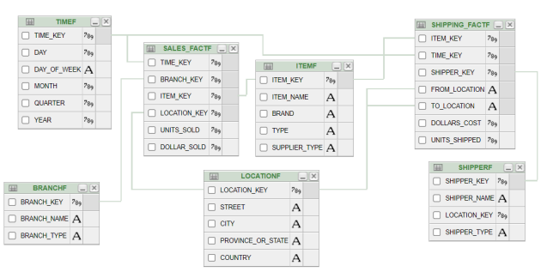

**RESULT:**

**Experiment-3**

**Table Creation:**

create table employee_details(id integer primary key, name varchar2(20), job varchar2(20), salary number(10));

insert into employee_details values(7369, 'kumar','clerk', 20000);

insert into employee_details values(7566, ' ram', 'manager ' ,40000);

insert into employee_details values(7654, ' surya', 'salesman ' ,25000);

insert into employee_details values(7499, ' ajay', 'salesman' ,30000);

insert into employee_details values(7521, ' prakash', 'salesman' ,35000);

insert into employee_details values(7788, ' arun', 'analyst' ,40000);

insert into employee_details values(7839, ' siva', 'president' ,80000);

**ROLL-UP:**

select name, id , job, sum(salary) as salary from employee_details group by rollup(name, id , job);

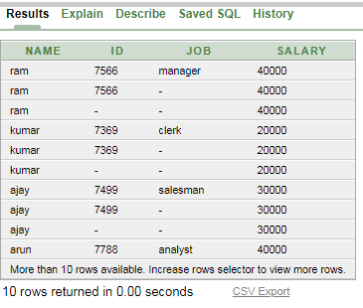

**DRILL-DOWN:**

select name, job, salary from employee_details;

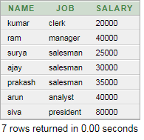

**SLICE:**

select *from employee_details where salary<40000;

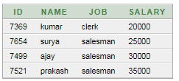

**DICE:**

select name, job , sum(salary) as "salary" from Employee_details where (salary > 20000 and job = 'salesman') group by name , job order by name asc;

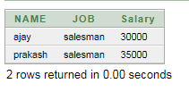

**PIVOT:**

select salary, max(decode(salary,'40000',name))ANALYST, max(decode(salary,'20000',name))CLERK,max(decode(salary,'40000',name))MANAGER ,max(decode(salary,'25000',name,'30000',name,'35000',name))Salesman, max(decode(salary,'80000',name))President from (select job,salary,name from Employee_details) group by salary order by salary;

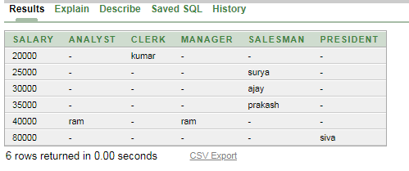

**RESULT:**